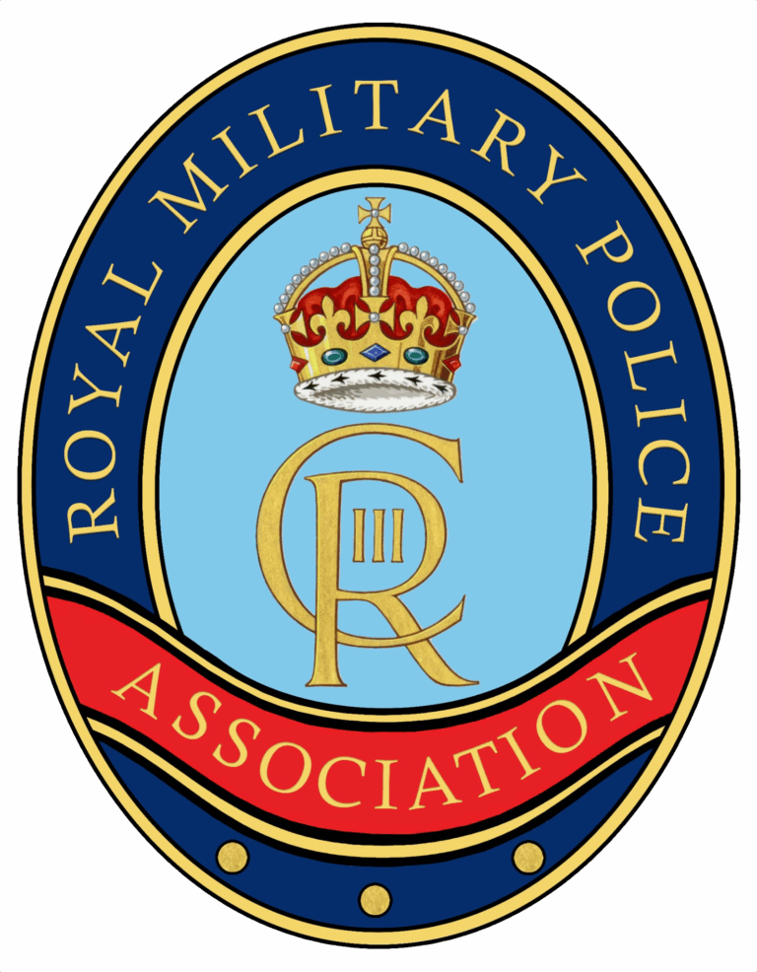
Introduction
The Standard Bearer is appointed by the RMPA Branch committee for this important post, and it is essential that the person selected is physically strong and well able to handle the Standard under all conditions.
Standard Bearers must be given access to a copy of Ceremonial procedures and encouraged to attend training sessions.
- https://rmpa.org.uk/standard-bearer-drills/
During any event, when a Standard Bearer is required to attend, the RMPA will make every effort to ensure their safety. However, as with any physical activity, there are health risks, and a minimum level of physical fitness is required.
The RMPA Branch / National Committee must carry out a risk assessment of the capability of the Standard Bearer.
If a Standard Bearer is deemed to be unfit to carry a Standard by the Branch / National Committee, he/she should be stood down from that position until declared medically fit.
Standard Bearers are required to also conduct their own Dynamic Risk Assessments prior to participating in an event, especially where RMPA Committee members are not present to evaluate potential risks.
Key Hazards to be Considered
- Manual Handling Injuries: Long periods of holding a heavy standard (flag), potential back strain, and arm fatigue.
- Trip/Fall Hazards: Uneven ground, steps, or obstacles, particularly while focused on holding the standard rather than watching their footing.
- Weather Conditions: Strong winds causing a "sail effect" on the standard, leading to loss of control, or wet, slippery surfaces.
- Crowd Movement: Collisions with the public, especially in tight, crowded, or unsecured areas.
- Environmental Hazards: Overhead power lines, low-hanging branches, or street furniture.
Risk Mitigation Measures (Control Measures)
- Training & Competence: Ensuring the standard bearer is physically capable and trained in proper handling and manual handling techniques (e.g., using a sling/bucket).
- Equipment Maintenance: Regular inspection of the pole, ferrule (metal tip), and harness for faults.
- Safe Handling Practices: Advising the bearer to "ask for help" if tired, take regular breaks, and secure the standard during breaks to prevent it from falling.
- Supervision & Support: Using marshals to guide the standard bearer, particularly in crowded areas, and ensuring they have assistance if needed.
- Route Planning: Pre-walking the route to identify hazards, ensuring clear, flat pathways, and avoiding congested areas.
- Weather Monitoring: Suspending, modifying, or cancelling the duty if wind speeds are too high.
Risk Assessment Steps
Step 1: Identify the hazards
Step 2: Decide who might be harmed and how
Step 3: Evaluate the risks and decide on precautions
Step 4: Record your findings and implement them
Step 5: Review your assessment and update if necessary
Risk Assessment Template
A Risk Assessment template can be downloaded from the following link:
- https://rmpa.org.uk/standard-bearer-drills/

Standard Bearer Declaration
I confirm that:
- I have read and understood the responsibilities and risks associated with Standard Bearing, including but not limited to:
  - Standard bearing is a physical activity and so I must ensure I am both physically fit and strong enough to carry a Standard in all reasonable weather conditions.
  - As a Standard Bearer I will be expected to be able to carry a Standard which is 8ft 5ins long and up to 3.5kg/4kg in weight (in wet or windy weather conditions Standards may become heavier and difficult to hold upright)
  - Some actions such as Dips may put a strain on the back and shoulders
  - Parades and Remembrance events may prove demanding and stressful for some.
- If I am in receipt of any disability related allowance or benefit, I will inform the appropriate authorities of my intention to undertake the role of Standard Bearer as this may affect my eligibility status.
To my knowledge, I have no physical conditions or disability that could potentially put me or others at harm whilst performing my duties as a Standard Bearer. If I have, or suspect I have, a health problem which means I may not be able to fulfil all duties required of the role safely, I undertake to inform the RMPA Chair and Secretary at the earliest opportunity.
RMPA STANDARD BEARER
RMPA BRANCH
NAME
ADDRESS
TELEPHONE
EMAIL (Personal)
By signing below, I confirm that: the statements in the Self Declaration to be true and, where a statement is not true, I have made a disclosure(s) to the National Committee which has been accepted by the RMPA and does not prevent me from carrying out this role; and that I will inform the RMPA of any changes in my circumstances which would affect the veracity of this declaration.
Signature: |  | Date:

Activity this Assessment is For: |  | Ceremonial Standard Bearer Duties
Description of task: |  | Individual will be required to perform ceremonial duties carrying a pole mounted Standard (flag) carrying out a variety of drills. Moving the pole and standard into various positions , which form part of a drill movement
Location
Load Weight (kg) |  | Frequency:
Carry Distance: |  | Floor Type:
Hazard Assessment Checklist: ü as appropriate
Does the task involve: |  |  | Yes |  | No | Not Applicable
Task requires unusual strength or height?
Puts at risk those who are pregnant or have a health problem?
The individual requires special knowledge or training for the safe performance of the task?
Twisting
Stooping
Holding load away from body
Reaching upwards
Bending over
Long carry distances
Pushing or pulling
Repetitive handling
Infrequent Rest Breaks
About the load - is it
Heavy
Bulky
Difficult to grasp
Unstable/unpredictable
Slippery
Hazardous (example: hot, sharp, chemical)
Unusual shape
About the environment
Are there constraints on a person's posture
Uneven or sloppy floors
Stairs
Change in levels
Poor lighting
Strong air movement
Moving vehicles
Excessively hot, cold or humid
About the individual
Do they have health problems or disabilities
Are they pregnant
Are they fit and able bodied
Have they received manual handling training
Are they familiar with the environment

Other Factors
Is personal protective equipment provided
Is lifting or moving equipment available
Further Assessment Information:
After completing the above checklist, consider if any other factor is relevant which could help or hinder the respective activity being carried out.

